WINTER SPRINGS
HIGH SCHOOL
50 DEFENSE
D-LINE

WSHS 50 DEFENSE: DL
ALIGNMENT
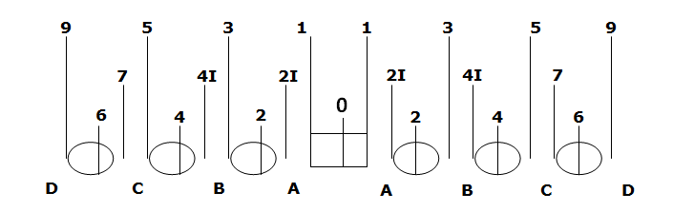
In the Winter Springs 50 defense you are responsible for knowing and executing the technique (or shade) and responsibility (or gap) on every play. Even numbers represent head up techniques on offensive blockers. Odd numbers represent outside techniques on offensive blockers. It is critical to understand the strength call. The linebackers will call the strength of the formation (RIGHT or LEFT) and we must be able to determine if we are to the call or away from the call in order to get properly aligned. (ex: In 50 Slant, the Nose and the Tackle to the called strength slant inside. If strength call is LEFT. The Left side tackle and Nose would slant inside).
STANCE
FEET: Feet should be as parallel as possible. Your feet should be shoulder width apart. You should be on the “balls” of your feet with your knees in and heels slightly off the ground. Play with good knee bend ready to explode out of your stance.
ARMS: In a three-point stance your shade hand will always be down. As a general rule of thumb if you are on the left side of the line your right hand will be down, if you are on the right side of the line your left hand will be down. The foot on the same side as your down hand should be slightly back (front toe to middle of foot relationship) and you should always step first with that foot. Your hands should be on your fingertips. NOT on knuckles or palms ! 70 % of your weight is on your fingertips. You are a “coiled spring” ready to explode. Hand should be directly under your eyeball.
BACK: Back should be relatively flat with your butt about even to slightly over your head.
HEAD: Head should be up with your eyes focusing on straight ahead, keying the football for movement.

WSHS 50 DEFENSE: DL
KEYS FOR SUCCESS
GET OFF: Key the football. Do not listen to the offense’s cadence or snap count. Think small; focus on the front tip of the football or the screw on the helmet. As soon as it moves get into your first step.
FIRST STEP: Make sure to step with the same foot as your down hand. The first step should be short – about six inches or should replace your down hand. A short first step allows us to stay balanced, gives us a stronger base of power, and allows us to get off of blockers quicker than a long step. A long first step will get us unbalanced and caught upfield, opening up gaps for the offense to run through and will get you knocked down frequently.
FIRE OUT! NOT UP!: When we fire out of our stance our helmet shouldn’t rise and our butt should slightly sink as we load up to fire with our hips and arms on our second step. By rolling our hips on the second step and maintaining a flat back we explode into blockers with immense power and do not allow them to get to our chest. STAY LOW! Hide your numbers! Man with the lowest pad level will win the battle!
HANDS: We want to play through the V of the neck of the blocker we are on. Wherever he goes, we go with him. We want our hands to be tight together and aiming for the blockers numbers. The man who has his hands inside on the chest has control over his man. Our elbows should be tight together and we should strive to lock our arms out completely to keep the blocker as far away as possible from us. We should violently grab cloth and be ready to throw our blocker out of the play.
FLAT DOWN THE LINE: We always want to play parallel and side to side down the line of scrimmage. Our shoulder should never turn towards or away from a blocker, we should stay as square as possible to the line of scrimmage that way we can react in any direction. It is also important we NEVER get too far upfield (unless it is a pass), we should strive to play no more than 1 yard into the backfield; then get flat and play lateral down the line of scrimmage.
VIOLENT RELEASE: It is important that we never raise up and peak over a offensive lineman’s shoulder to locate a ball carrier. We should stay low (our helmet below his helmet); trust and follow our hands on an offensive blocker and let him take us to the play. By our fourth to fifth step we should be violently releasing off our blocker with a rip move or by violently pulling him down in a direction away from our body.
SITUATIONS: Pay attention to game situations. If it is third and long expect the pass, draw, or screen. You can elongate your stance and have a pass rush move in mind. If the team is constantly double-teaming with a tight end be aware when they put a tight end to your side. If it is 4th and short be aware that they may try to draw us offsides with a hard snap count. Offensive lines will also play with their splits (distance between each offensive lineman) if there is a wide split; chances are they are trying to run the ball inside of you. Be Smart! Recognize tendencies.
WSHS 50 DEFENSE: DL
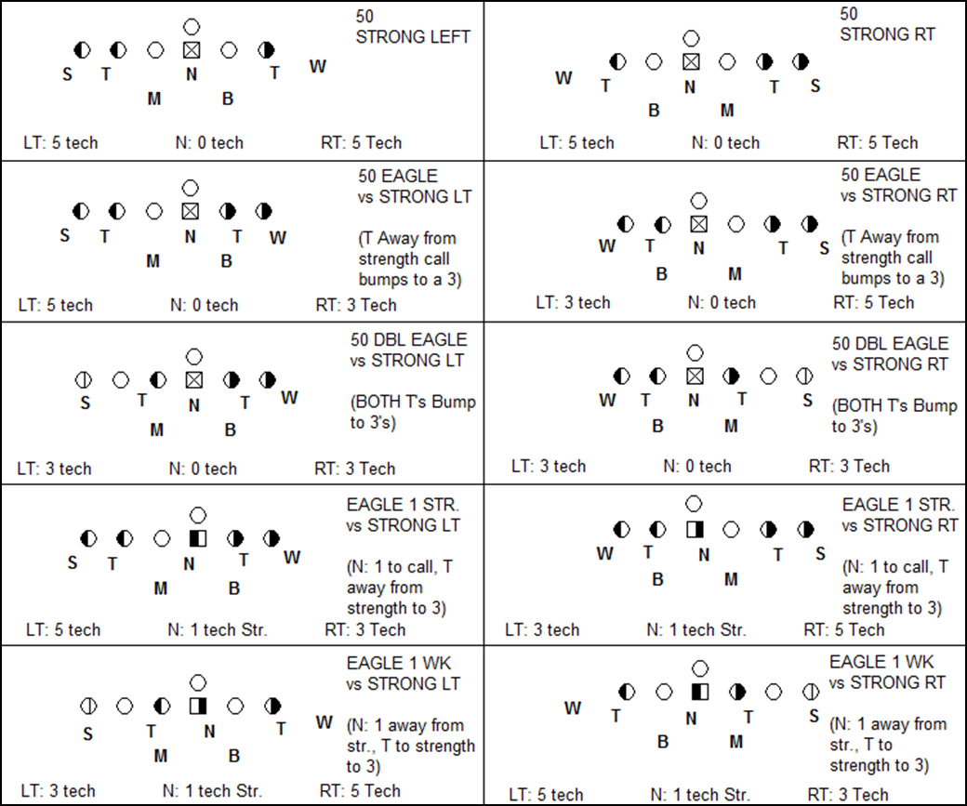

WSHS 50 DEFENSE: DL

WSHS 50 DEFENSE: DL

